Maribor, 18th – 19th of September 2013

INTERNATIONAL FINAL CONFERENCE OF THE PMinter PROJECT
Program

Day One – Wednesday, 18. 9. 2013 / 9.00 – 18.00

9.00 Registration of Participants
9.15 – 9.45 Press Conference
10.00 – 10.30 Welcome Speeches
Dr. Andrej Fištravec, Mayor of Maribor and host of the conference
Mag.ª Monika Kirbiš Rojs, State secretary, Ministry of Economic Development and Technology of the Republic of Slovenia
Herr Rolf Holub, Member of the regional government of Carinthia, Austria
Dr. Gerhard Kurzmann, Member of the regional government of Styria, Austria
Mag.ª Tanja Bolte, Representative of the Ministry of Agriculture and the Environment of the Republic of Slovenia, Environment directorate

10.30 – 12.00 1st session – Air quality monitoring, part one

Anton Planinšek  Slovenian Environment Agency, Slovenia | Ambient Air Quality in Slovenia
Mag. Benjamin Lukan, Uroš Lešnik  Institute of Public Health Maribor, Slovenia | Air Quality in Maribor – Why Additional Measurements?
DI Gerhard Heimburger  Office of the Carinthian Government Amt der Kärntner Landesregierung, Austria | Fine Dust (PM₁₀) and Benzo(a)pyrene (B(a)P) in Carinthia
Dr. Griša Močnik  Aerosol, Slovenia | Source Apportionment of Black Carbon and Carbon and Carbonaceous Matter within PMinter: Klagenfurt, Maribor, Leibnitz

12.00 – 12.15 Coffee Break

12.15 – 13.30 1st session – Air quality monitoring, part two

Dr. Anne Kasper-Giebl  TU Vienna, Austria | Macrotracer Model for Fine Dust Source Mapping (PM₁₀) at 7 PMinter Air Quality Measuring Stations (February 2011)
Dr. Magdalena Kistler  TU Vienna, Austria | Chemical Composition of PM₁₀ from Small-scale Combustion Plants – Factors for the Macrotracer Model
DI Dr. Thomas Brunner  TU Graz, Austria | PM Emission Measurements at Biomass Small-scale Combustion Plants in Carinthia, Southern Styria and Slovenia

13.30 – 14.30 lunch

14.30 – 15.30 2nd session – Impacts on health

Dr. Ivan Eržen  Institute for health protection Ljubljana, Slovenia | Ultrafine Particles in the Ambient Air and Health
Dr. Hans Peter Hutter  Medical University of Vienna, Austria | Health Effects of Particulate Matter: Exposure and Research in Austria

15.30 – 17.30 3rd session – Modelling

Dr. Rahela Žabkar  University of Ljubljana, Slovenia | Regional Modelling of Episodes of Excessive Ambient Air Pollution on the Area of Slovenia
Ondřej Vlček  Czech Hydrometeorological Institute, Chech Republic | Forecasting PM in the Czech Republic
Dr. Ulrich Uhrner  TU Graz, Austria | PMinter Air Quality Simulations – a New Holistic Approach

17.30– 18.00 Summary of the first day

19.00 Dinner

Day Two – Thursday, 19. 9. 2013 / 9.00 – 13.15

9.00 – 11.00 4th session – Measures, part one

Mag. Tanja Bolte  Ministry of Agriculture and Environment, Slovenia | Joint Planning and Implementation of the Air Quality on the Level of the State and the City of Maribor
Brigita Čanč, spec.  Municipality of Maribor, Slovenia  Dr. Marjan Lep  University of Maribor, Slovenia | Preparation of the Ambient Air quality Plan for Maribor
Dr. Marjan Lep  University of Maribor, Slovenia | Low Emission Zone in Maribor

11.00 – 11.15 Coffee Break

11.15 – 12.00 4th session – Measures, part two

Dr. Wolfgang Hafner  Municipality of the City of Klagenfurt, Austria | Fine Dust Free Klagenfurt? Measures for the Reduction of Air Pollution in the State Capital Klagenfurt am Wörthersee
DI Dr. Thomas Pongratz  Styrian Government , Austria | The Styrian Clean Air Programme 2011 – Measures to Improve Air Quality

12.00 – 13.00 5th session – Best practices

Dr. Ulrich Teichmann  City of Munich, Germany | Ambient Air Monitoring in the State Capital Munich since 2004
Irena Razpotnik  Municipality of Ljubljana , Slovenia | Sustainable Mobility Plan - Electromobility Strategies in the City Municipality of Ljubljana  Project Bicike(LJ) - Success since 2011 and Expansion Plans

13.00 – 13.15 Summary of the second day

13.15 – 14.00 Lunch

From 15.00 Activities in connection with European mobility week
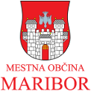
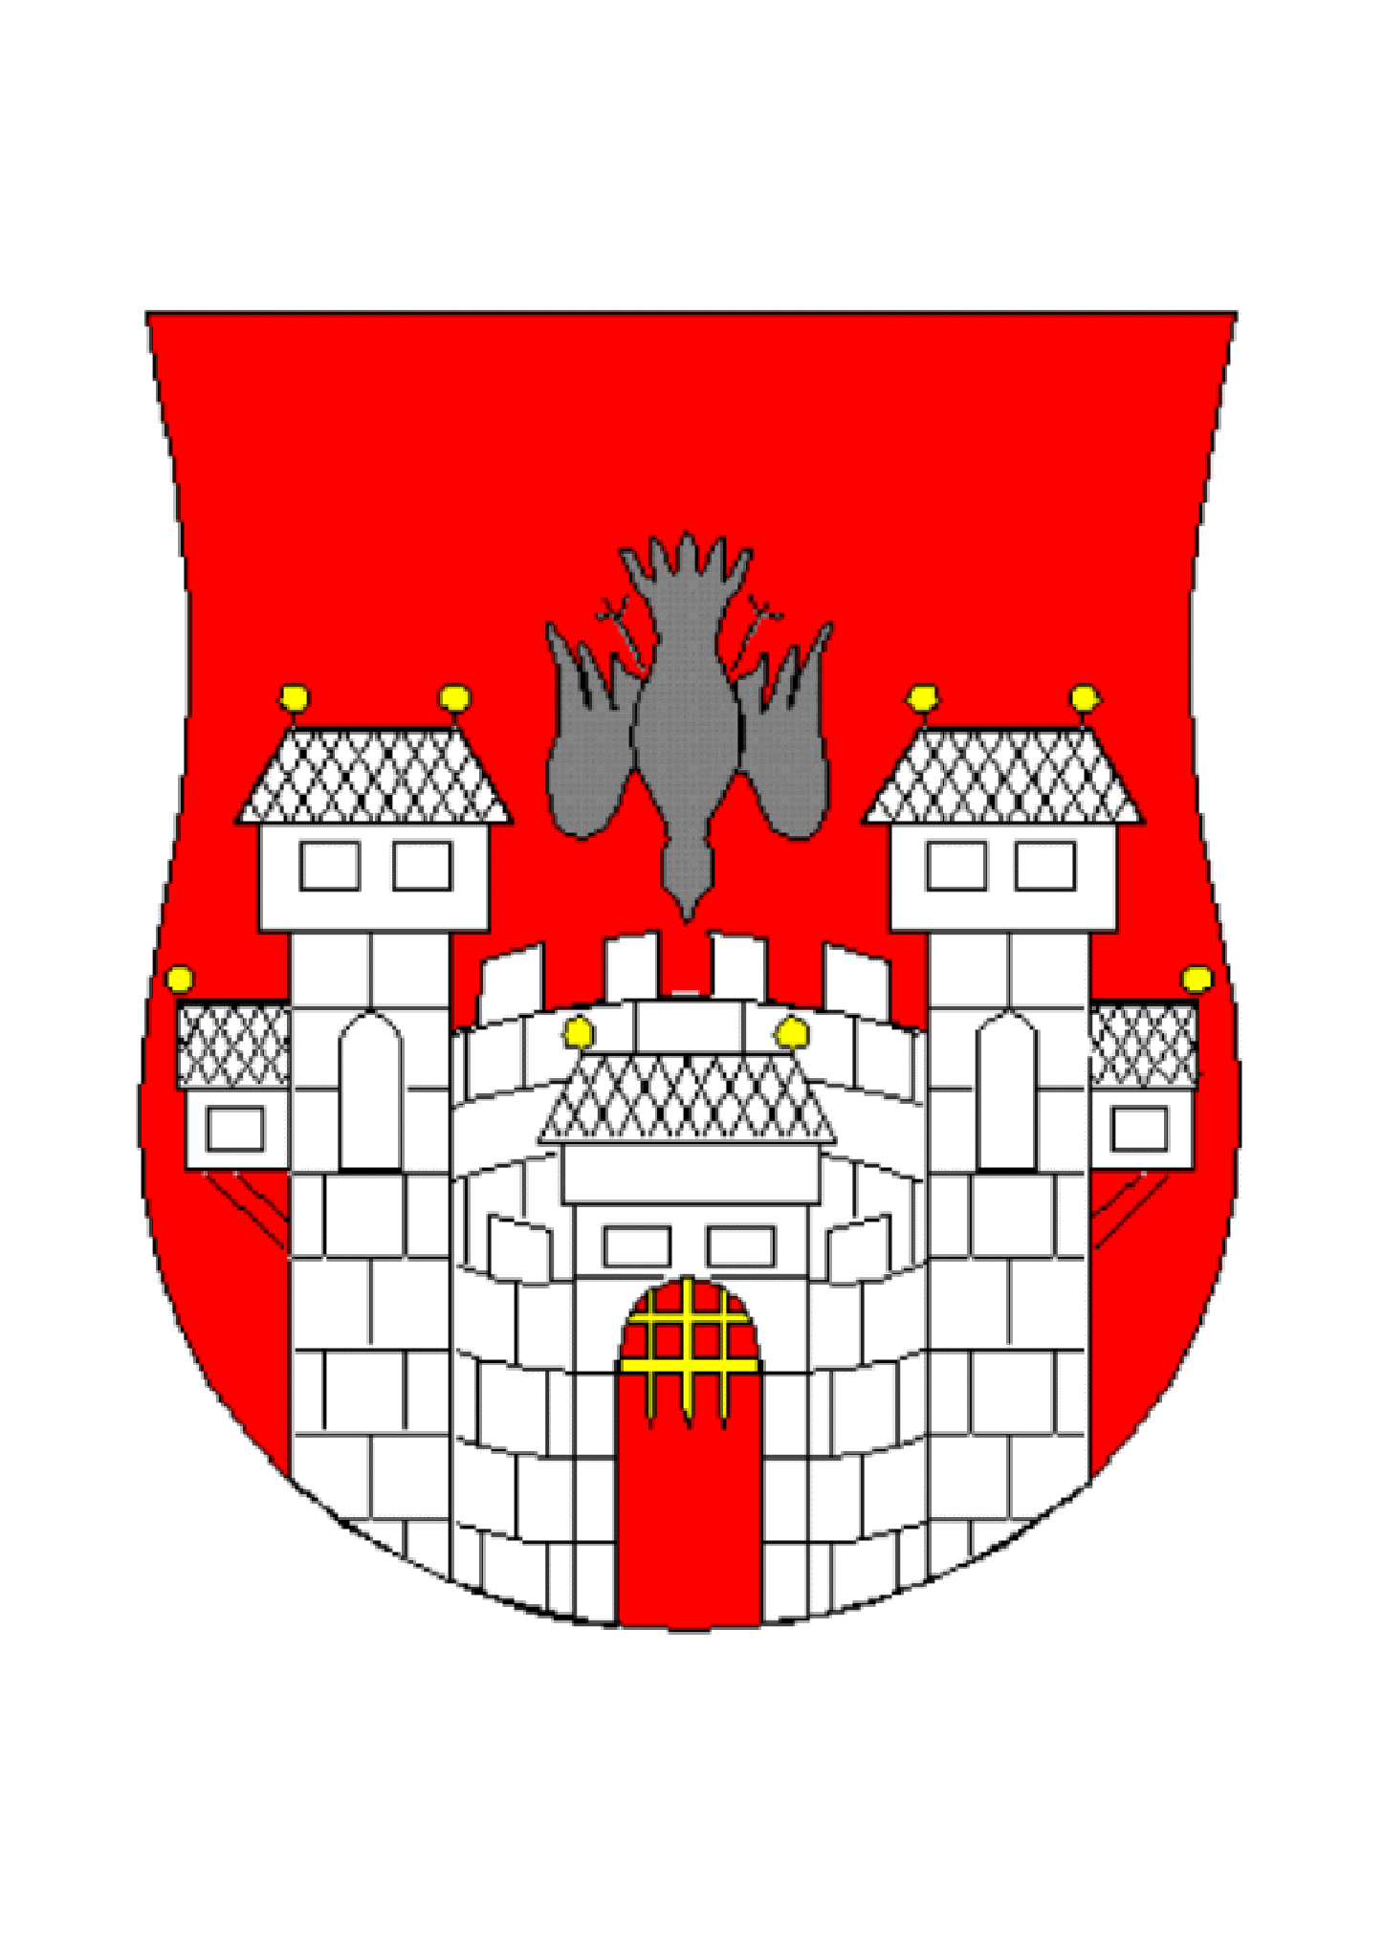
MUNICIPALITY OF MARIBOR

